Created by Shivam Volvoicar

**Contractzy**

**Test Plan** **1**

Objective 2

Scope 2

Inclusions 4

Test Environments 6

Defect Reporting Procedure 7

Test Strategy 8

Test Schedule 9

Test Deliverables. 10

Entry and Exit Criteria 10

Entry Criteria: 10

Exit Criteria: 11

Test Execution 11

Entry Criteria: 11

Exit Criteria: 11

Test Closure 11

Entry Criteria: 11

Exit Criteria: 11

Tools 11

Approvals 12



**Title:** Document Risk Analysis and Guidebook Creation for Contract Management

**Description:** We are implementing a feature that allows users to perform risk analysis on contract documents based on predefined guidebooks. The user will be able to create guidebooks, categorize clauses, and assign risk scores to them. When a document is uploaded or created, users can analyse it using the selected guidebook, which will evaluate the document’s clauses and provide a detailed report on potential risks, mandatory clauses, and suggestions for improvement.

**Acceptance Criteria:**

1. **Guidebook Panel:** A vertical sliding panel should appear when accessing a document through the editor. This panel should contain a list of guidebooks with multiple guidelines.
2. **Guideline Exploration:** Users should be able to explore each guideline in the guidebook.
3. **Analyse Button:** Each guideline should have an "Analyse" button. Upon clicking the "Analyse" button:
   * A list of risks related to each clause in the document should be displayed.
   * Suggestions for replacing or improving errored clauses should be provided.
   * Each clause should be categorized as **Enforce**, **Normal**, or **Optional**, with a risk score calculated based on its category.
4. **Risk Score Display:** The total risk score should be displayed in the panel, along with specific errors or issues related to each clause.
5. **Guidebook Creation:** Users should be able to create custom guidebooks.
   * They can add clauses and define their category (Enforce, Normal, Optional).
   * Clauses can be marked as mandatory while creating the guidebook.
6. **Contract Category Selection:** When creating a contract, users must select a contract category (e.g., On-premise Software Agreement), and the guidebook’s clauses should be applied based on this selection.
7. **Clause Application:** The clauses categorized as mandatory should be applied when scanning a document based on the selected guidebook.

The schedule and milestones for the testing, including the start and end dates, and the planned testing activities.

The tools and equipment that will be used for testing, such as testing software, hardware, and documentation templates

## **Inclusions**

Introduction: This section would provide an overview of the test plan, including its purpose, scope, and goals.

Test Objectives: This section would outline the specific objectives of the testing, such as identifying and fixing defects, improving the user experience, or achieving a certain level of performance.

**Login Page:**

## 

**AI (Guidebook):**

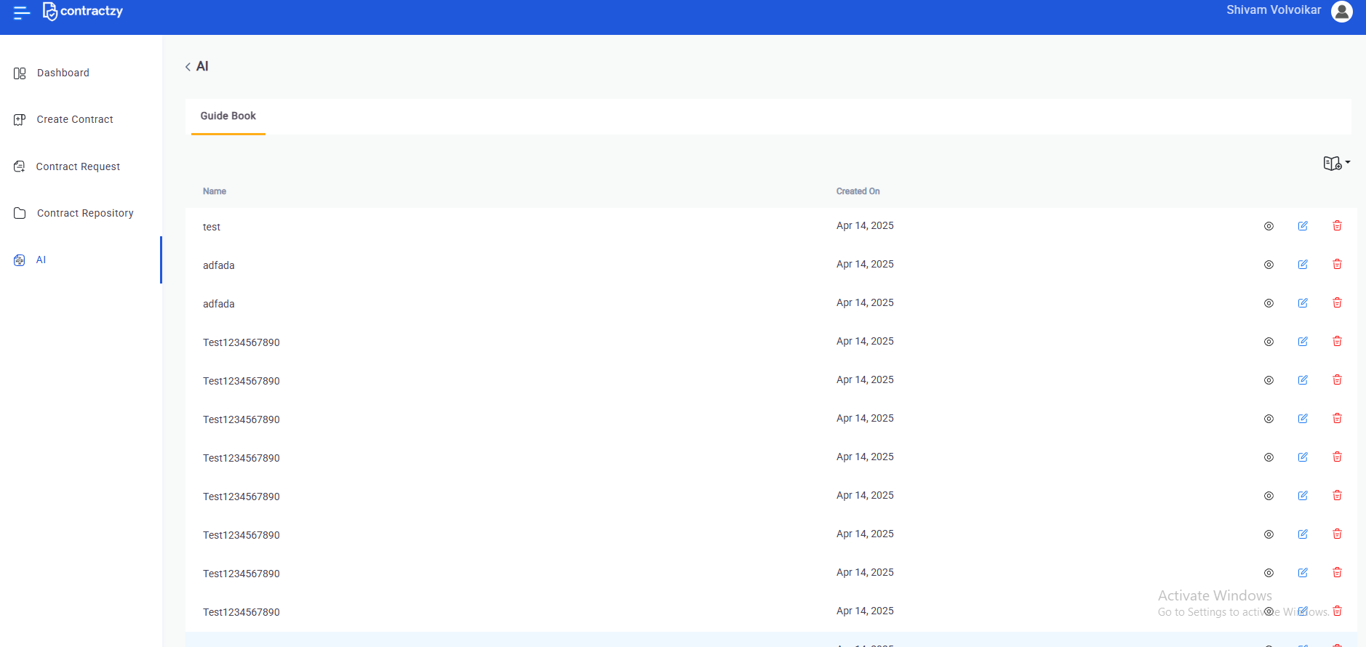​

**Create Contract:**

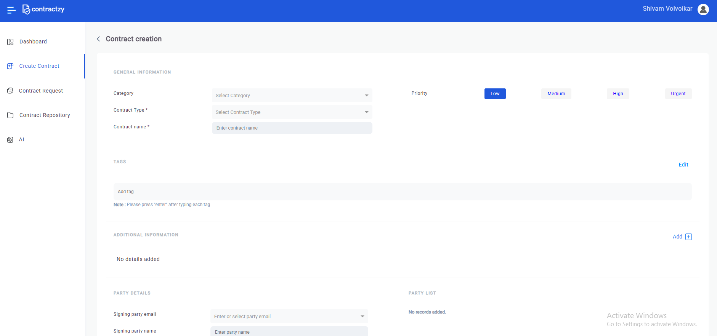

**Risk Analysis :**

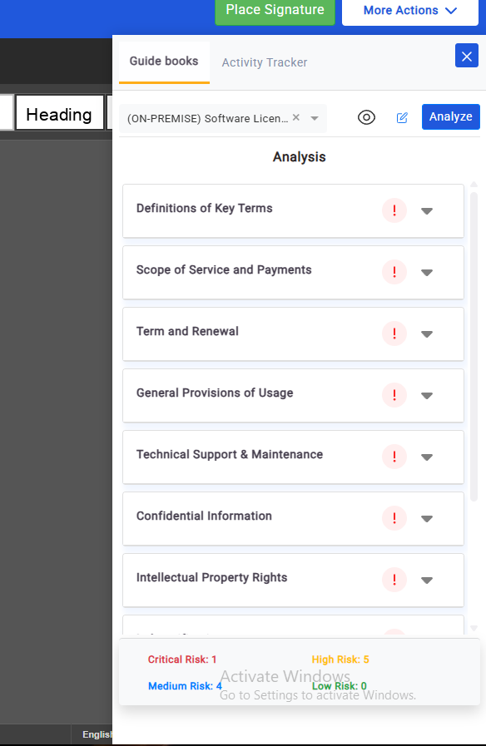

## Test Environments :

**Operating Systems :**

**1.Windows**

**2. MacOS**

**Browsers :**

**Chrome**

**Mozilla Firefox**

**Edge**

**Brave**

**Safari**

**Devices:**

**Desktop versions**

## Defect Reporting Procedure

The criteria for identifying a defect, such as deviation from the requirements, user experience issues, or technical errors.

The **steps for reporting a defect**, such as using a designated template, providing detailed reproduction steps, and attaching screenshots or logs.

The **process for triaging and prioritizing defects,** such as assigning severity and priority levels, and assigning them to the appropriate team members for investigation and resolution.

The **tools and systems** that will be used for tracking and managing defects, such as a defect tracking software / google doc

The **roles and responsibilities of the team members** involved in the defect reporting process, such as testers, developers, and the test lead.

Tools - JIRA, Google Docs, Google Sheets

## **Test Strategy**

The first step is to create test scenarios and test cases for the various features in Scope.

While developing test cases, we'll use a number of test design techniques.

* Valid scenarios (correct username and password).
* Invalid scenarios (incorrect username or password).
* Boundary value testing (e.g., empty fields, maximum character limits).
* Error message verification.
* UI/UX considerations for the modules (e.g., button visibility, alignment, etc.).

We also use our expertise in creating Test Cases by applying the below:

* Error Guessing
* Exploratory Testing

Step 2: Our testing procedure when we receive a request for testing:

* First, we'll conduct analyze the documents and KT sessions and then as per that prepare necessary documents such as Test Suite
* Perform Smoke Test and check for obvious issues
* Once we receive a stable build, which passes Smoke Testing, we perform in depth testing using the Test Cases created.
* We then report the bugs in the bug tracking tool / Google docs and send dev. management the defect found on that day in a status end of the day email.

Step 3: As part of the Testing, we will perform the below types of Testing:

* Smoke Testing and Sanity Testing
* Regression Testing and Retesting
* Usability Testing, Functionality & UI Testing
* We repeat Test Cycles until we get the quality product.
* Exploratory Testing

## **Test Schedule**

Following is the test schedule planned for the project – Task Time Duration

| **Task** | **Dates** |
| --- | --- |
| * Creating Test Plan | N/A |
| * Test Case Creation | N/A |
| * Test Case Execution | N/A |
| * Summary Reports Submission Date | N/A |

### 

### **Tools**

The following are the list of Tools we will be using in this Project:

* JIRA / Google Doc
* Snipping Screenshot Tool
* Google Sheets
* Github

## **Test Closure**

### **Entry Criteria:**

* Test Case Reports, Defect Reports

### **Exit Criteria:**

* Test Summary Reports

### **Approvals**

Team will send different types of documents for Client Approval like below:

* Test Plan
* Test Suite
* Test Cases
* Reports

Testing will only continue to the next steps once these approvals are done